Test Case: tc001_SPX_Dev5_Consulta_Administracion_Accesos
Step 1 - Enter username and password and click to button Enter : Credentials Entered
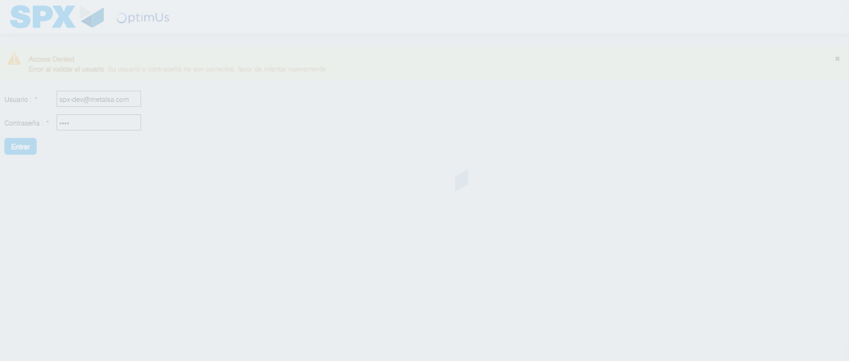Image file-name: QC_Testing-tc001_SPX_Dev5_Consulta_Administracion_Accesos-dic. 26 2025, 03 29 43 p. m.

Step 2 - Select to UEN and Access to Administraci�n de Accesos: UEN Correctly selected and Correct access
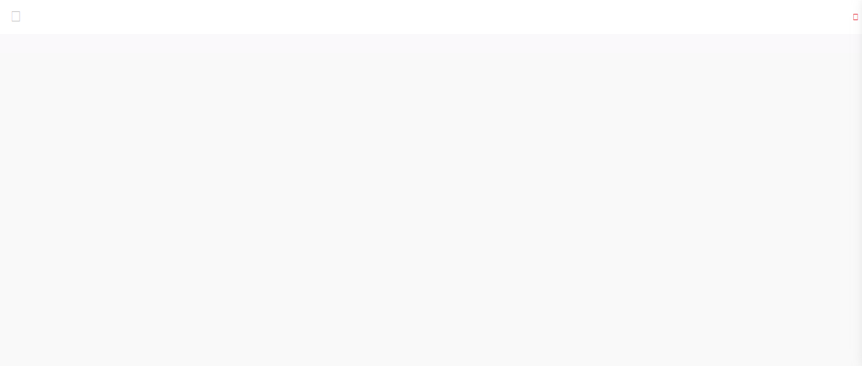Image file-name: QC_Testing-tc001_SPX_Dev5_Consulta_Administracion_Accesos-dic. 26 2025, 03 29 53 p. m.

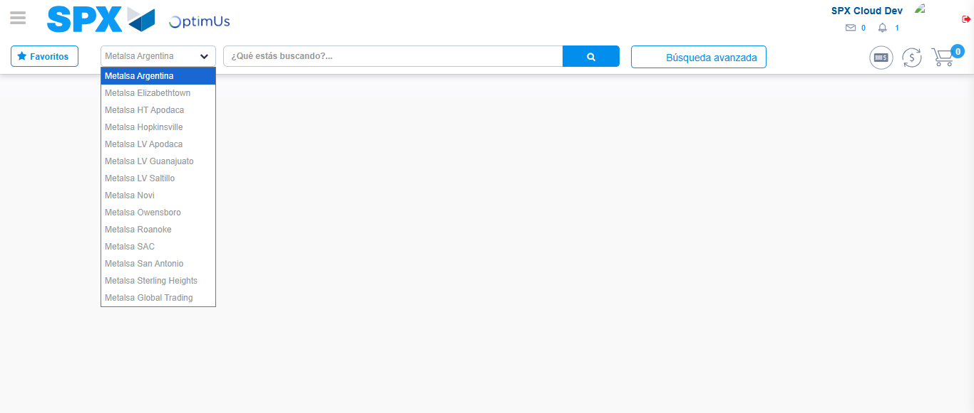Image file-name: QC_Testing-tc001_SPX_Dev5_Consulta_Administracion_Accesos-dic. 26 2025, 03 29 54 p. m.

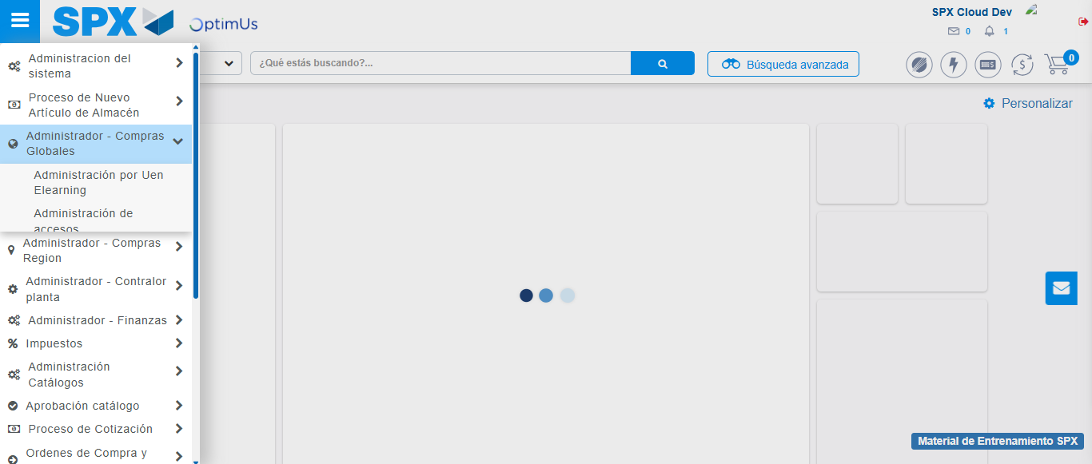Image file-name: QC_Testing-tc001_SPX_Dev5_Consulta_Administracion_Accesos-dic. 26 2025, 03 29 55 p. m.

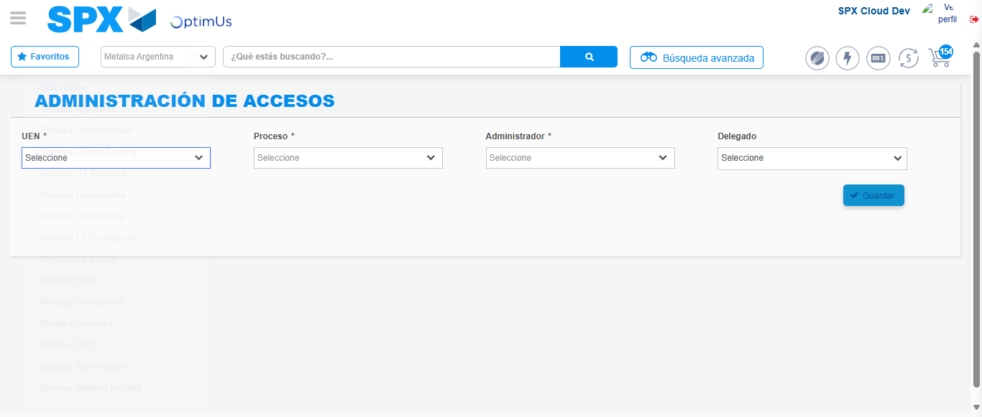Image file-name: QC_Testing-tc001_SPX_Dev5_Consulta_Administracion_Accesos-dic. 26 2025, 03 30 03 p. m.

Step 3 - Review information on Aprobaci�n Catalogos: Correct Data
Image file-name: QC_Testing-tc001_SPX_Dev5_Consulta_Administracion_Accesos-dic. 26 2025, 03 30 03 p. m.

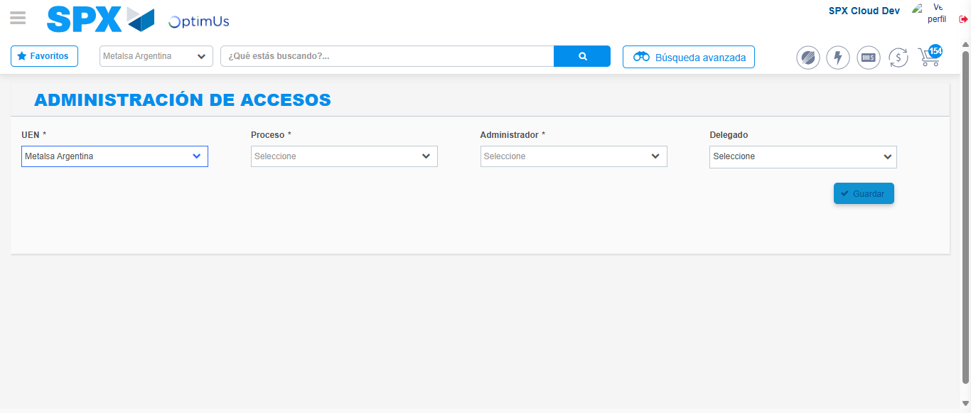Image file-name: QC_Testing-tc001_SPX_Dev5_Consulta_Administracion_Accesos-dic. 26 2025, 03 30 04 p. m.

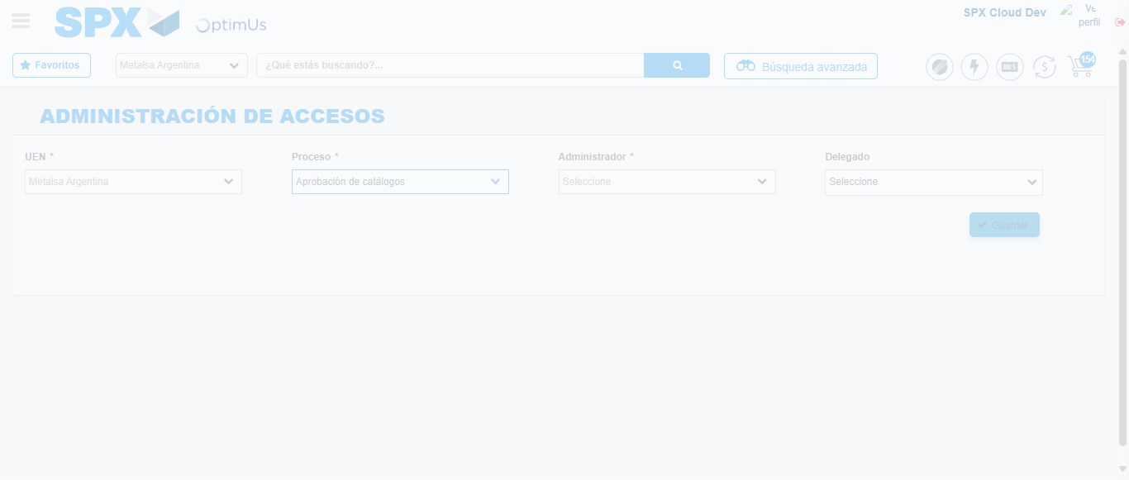Image file-name: QC_Testing-tc001_SPX_Dev5_Consulta_Administracion_Accesos-dic. 26 2025, 03 30 07 p. m.

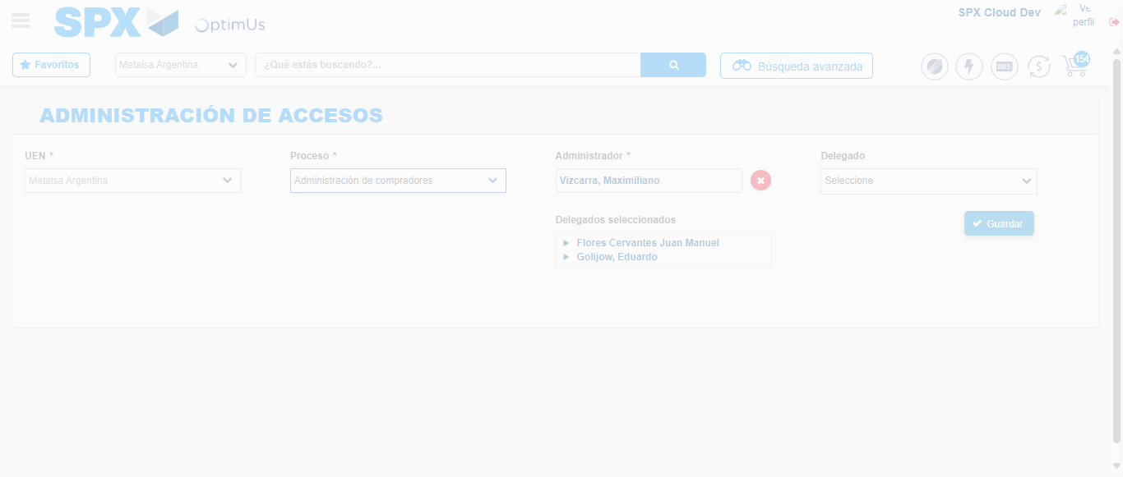Image file-name: QC_Testing-tc001_SPX_Dev5_Consulta_Administracion_Accesos-dic. 26 2025, 03 30 11 p. m.

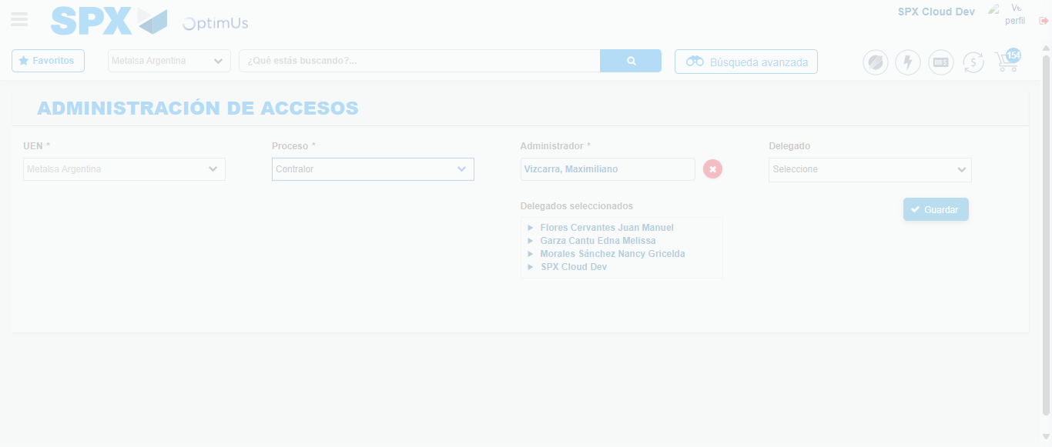Image file-name: QC_Testing-tc001_SPX_Dev5_Consulta_Administracion_Accesos-dic. 26 2025, 03 30 15 p. m.

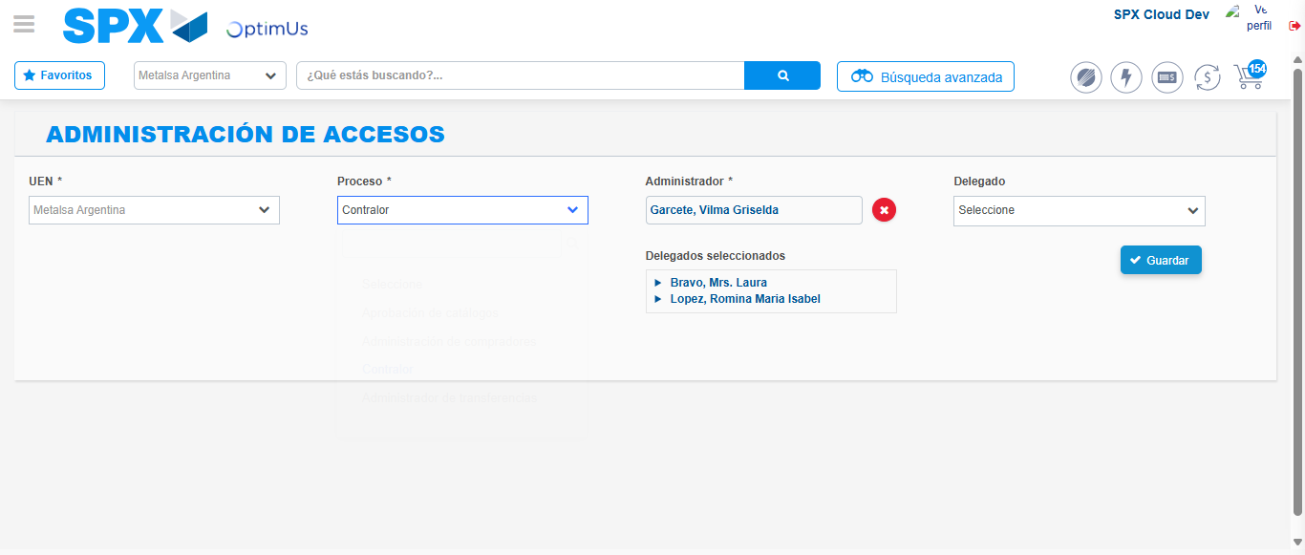Image file-name: QC_Testing-tc001_SPX_Dev5_Consulta_Administracion_Accesos-dic. 26 2025, 03 30 18 p. m.

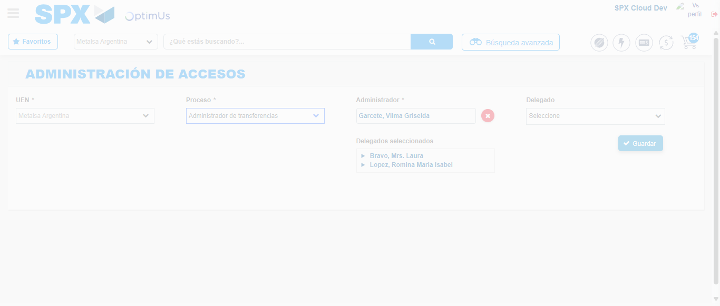Image file-name: QC_Testing-tc001_SPX_Dev5_Consulta_Administracion_Accesos-dic. 26 2025, 03 30 19 p. m.

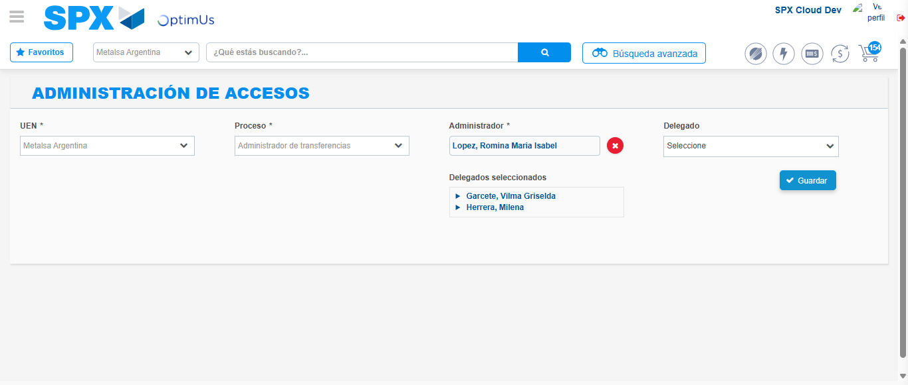Image file-name: QC_Testing-tc001_SPX_Dev5_Consulta_Administracion_Accesos-dic. 26 2025, 03 30 22 p. m.

